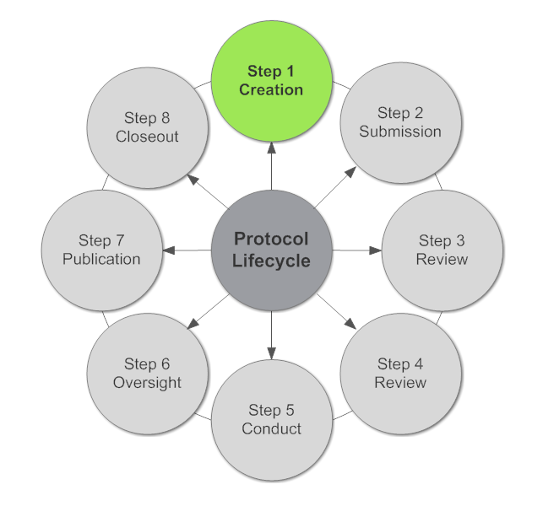
Human Subjects Research
Protocol Guidance

A research protocol describes planned research activities. It is the plan submitted to an Institutional Review Board (IRB) for review and may be submitted to a sponsor for research support/funding. The research plan includes a description of the research design or methodology, how prospective research participants are chosen, a description of what will happen during the study, and what data analysis will be used on the data collected. The protocol should describe the common question questions: Who, What, When, Where, How, and Why.
MH IRB
Guidance
v.1.2020
Human Subjects Research Protocol
General Instructions

Page Setup

Suggested Font: Arial or Calibri, 12 pt.

Margins: Left/Right – 1 inch
Top/Bottom – 1 inch

Pagination: Protocol pages must be numbered and centered at the bottom of the page (upon IRB approval, a stamp will be placed in the right footer).

- Introduction – the introduction should be a succinct summary of the study and include the background and rationale. Explain why the research should be done, is interesting to the field, has value, etc. Describe the current environment that is the basis for the proposed research, including a presentation of the problem (with cited references) and a summary of the review of current literature. Include a critical evaluation of current knowledge, describe any preliminary or pilot studies conducted related to the proposed research, and describe how this protocol will enhance this knowledge. If applicable, the introduction should also mention the funding source.

- Hypothesis/Key Questions – define the hypothesis; the key questions being asked in the research study. The research question should be clear and include: the population (participant age, gender, ethnicity, disorder, etc.), intervention (what you plan to do), control/comparison (the main alternative choice - what you are testing or comparing), and the outcome measure (specifics on how success is measured).
Example:
Weak question: Do surgical dressings help prevent surgical site infections?
Strong question: In the adult surgical patient population, with chest tubes, is a bacitracin dressing better than a dry dressing at preventing surgical site infection?
- Research Objectives and Purpose – provide additional goals and rationale expanding upon the hypothesis (this can be combined with the Hypothesis section above). Identify specific, primary objectives. Secondary objectives should be described as necessary.

- Research Methods - describe the study procedures, assessments, and subject activities.
- Study design: explain the study design and choice of research methodology.
- Statistical bias: measures taken to avoid bias, if relevant. If random sample, how will sample be chosen?
- Study procedures: what will happen to the participants in the study? If there is deception involved, describe how subjects are deceived and the debrief processes.
- Study duration: how long will the study last and explain the expected duration of subject participation?
- Data collection: specify the data to be collected and the mechanism for tracking.
- Standard tools: as applicable, describe what tools will be utilized (Survey, Quality of Life questionnaire, etc.)
- Study schedule: provide a schedule of all study assessments and subject activities, including a tabular representation, schema, or timeline, as applicable.

- Study Participants
- Number of subjects to be enrolled (if there is more than one subject group, provide the enrollment break-down for each group and if randomization will occur).
- Subject selection procedures:
  - Sampling plan: If applicable, explain how sampling will occur? Include sample size determination and power analysis.
  - Inclusion/exclusion criteria: subject and disease characteristics
  - Who will participate in the research?
  - How will they be selected?
  - Why are they the target subject population (disease group, response to treatment, prior therapy)?
  - Why is someone else not included, i.e. why only men and not women?
- If you are including any vulnerable populations (children, pregnant women, prisoners, mentally ill, mentally challenged, or where literacy is a concern) in your project, state age range, gender, why this is important, and what the benefits are to the specified participants, as warranted.
- Recruitment procedures:
  - Where will recruitment occur?
  - What is the advertising plan, if applicable?
  - What recruitment materials will be provided to the potential participant (brochure/information sheets/video presentation)?
- Consent procedures:
  - Where, when, and how will consent be obtained?
  - Who will obtain consent?
  - Where will the signed copy of the consent form be kept?
  - Or, if applicable, have you requested a waiver of consent and why?
  - Include copy of consent that will be used
  - Is it understandable? (6th-8th grade reading level)
- Screening procedures, if applicable:
  - What procedures are required for screening?
  - What is the screening schedule (number of visits, length of visits, etc.)?
  - Which screening tests/procedures are part of standard care, and which are for research purposes only?
  - What happens with screen failures (including any data gathered during screening)?
- Withdrawal of subjects, if applicable:
  - How will participant withdrawal be addressed?
  - Will data collected until point of withdraw be kept or discarded?

- Statistical Analysis, as applicable
- Statistical methods including interim analysis, if appropriate.
- Primary and secondary endpoints.
- Level of significance to be used.
- Handling of missing data in the analysis.
- Criteria for terminating the study, or early stopping rules, if appropriate.
- Procedures for reporting deviations from the original plan.
- Anticipated Results and Potential Pitfalls: explain what you hope to find out, any problems or adverse events you think you might encounter, and suggest solutions. In particular, the IRB is interested in problems that may affect risk level, subject’s willingness to participate, feasibility of doing the research, etc.

- Data and Safety Monitoring Plan
- Confidentiality: describe what measures are in place to protect the data you are collecting.
- Privacy: describe how participant privacy will be maintained.
- What procedures will be used to monitor subject safety or accuracy of data?
- What are the stopping rules with regard to efficacy or safety?

- Record Keeping
- Record Retention: outline where and for how long records will be maintained for this study.
- Regulatory Binder: describe who will be responsible for maintaining the regulatory documentation and where this will be maintained (please note that these records may be requested for review for quality assurance purposes).

- Literature Review/References - the bibliography compiled to support the research question as referenced in this document.

Please understand if you need help or examples just ask.
Human Subjects Research Protocol Outline
Name of principal investigator (PI):
Name of co-investigator(s):
Protocol Version Date:
- Introduction
- Hypothesis/Key Question
- Research Objectives and Purpose
- Research Methods
  - Study design:
  - Statistical bias:
  - Study procedures:
  - Study duration:
  - Data collection:
  - Standard tools:
  - Study schedule:
- Study Participants
  - Number of subjects to be enrolled
  - Subject selection procedures:
  - Vulnerable populations
  - Recruitment procedures:
  - Consent procedures:
  - Screening procedures, if applicable:
  - Withdrawal of subjects, if applicable:
- Statistical Analysis
- Data Safety Monitoring Plan
- Record Keeping
- Literature Review/References

